**PSS-420011**

**4-in-1 IAQ Gas (CO, H2S, O2, CH4)Sensors**

**Polysense PSS-420011 is designed for various places requiring environmental gas detection, including four types of gas sensors (CO, H2S, O2, CH4 and other gases can be expanded). With good selectivity and stability, the module can output the current concentration values of four gases in real time through the digital serial port.**

**Can be used together with different communication intelligent terminals WxS, The detection data can be transmitted with Wifi, LoRaWan, NB-IoT, and LTE Cat1/M to the cloud IoT platform.**

**Detection principle**

Carbon monoxide CO, hydrogen sulfide H2S and oxygen O2 are electrochemical detection. The electrochemical structure is a three electrode structure. The principle of electrochemical detection is that the compounds on the sensor change according to the concentration of the ambient gas, the conductivity changes, and the voltage value output by the module changes accordingly to obtain the concentration data.

Methane CH4 is the principle of catalytic combustion. At a certain temperature, combustible gas will be catalytic combustion on its surface. Combustion is a function of the concentration of combustible gas when platinum resistance temperature rises and resistance changes.

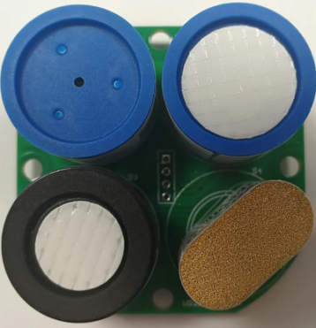**Product features**

* Detect item: carbon monoxide CO, hydrogen sulfide H2S, oxygen O2, methane CH4
* High integration
* Good stability and fast response
* Real time serial port output concentration

**Product parameters**

|  |  |
| --- | --- |
| **Parameters** | |
| Detection gas | CO,H2S,O2,CH4 |
| Measuring range | CO ：（0-1000）ppm  H2S：（0-100）ppm  O2 ：（0-30）%VOL  CH4：（0-100）%LEL |
| Resolution | CO ：1ppm  H2S：1ppm  O2 ：0.1%VOL  CH4：1%LEL |
| Working voltage | （3.5~5）V |
| Operating current | <100mA |
| Response time | <30s |
| **Interface** | |
| Output signal | UART |
| **Mechanical** | |
| Size | 46mm*46mm*21.6mm |
| Working temperature | -20℃～50℃ |
| Operating humidity | 15%RH~90%RH |
| Storage temperature | 0 ℃~20 ℃ (recommended) |
| Life expectancy | 2 years (in normal air) |
| **Power** | |
| Power | 3.5~5V |

**Application**

It can be used in the environment of plant gas leakage, underground operation, tunnel detection, coal mine detection, etc. It can be worn or held by human body to enter the detection site, or it can be used in fixed sites to detect the current ambient gas concentration and remind personnel of safety.

**Ordering Guide**

* PSS-420011 sensor is a sensor only; it needs to be used with WxS terminals to built into different product series;
* WxS terminal supports up to 8 PSS sensors by default;
* According to the use case, the enclosure and antenna of the WxS terminal will be replaced to ensure the product quality and performance.
* Example of combined products as follows:
* WxS7800-420011 WiFi Version 4-in-1 IAQ Gas (CO, H2S, O2, CH4) Sensors &RTU 2-in-1 Terminal
* WxS8800-420011 LoRaWAN Version 4-in-1 IAQ Gas (CO, H2S, O2, CH4) Sensors &RTU 2-in-1 Terminal
* WxS9800-420011 NB-IoT Version 4-in-1 IAQ Gas (CO, H2S, O2, CH4) Sensors &RTU 2-in-1 Terminal
* WxS9900-420011 LTE CatM Version 4-in-1 IAQ Gas (CO, H2S, O2, CH4) Sensors &RTU 2-in-1 Terminal
* WxSC800-420011 LTE Cat1 Version 4-in-1 IAQ Gas (CO, H2S, O2, CH4) Sensors &RTU 2-in-1 Terminal
* WxSD800-420011 LTE Cat4 Version 4-in-1 IAQ Gas (CO, H2S, O2, CH4) Sensors &RTU 2-in-1 Terminal
* CxS1800-420011 Ethernet (RJ45) Version 4-in-1 IAQ Gas (CO, H2S, O2, CH4) Sensors &RTU 2-in-1 Terminal